**Assignment 4 Pytorch**

**MLP**

1. **With and without dropout layer**

In my assignment I have modelled my network with and without dropout layer in MLP. It has 2 hidden layers My Network and model are shown below.

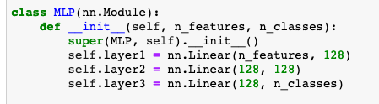

**With Dropout MLP**

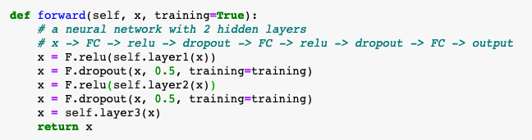

When I ran this code, the results are obtained as shown below:

batch_size = 250

epoch_num = 10

lr = 0.001

disp_freq = 20

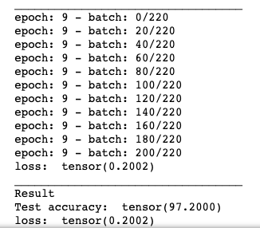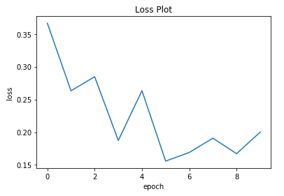

It performed significantly well with an accuracy rate of 97.2000 and loss of 0.2002.

Now let’s check without the dropout layers and compare.

**Without Dropout Layer MLP**

batch_size = 250

epoch_num = 10

lr = 0.001

disp_freq = 20

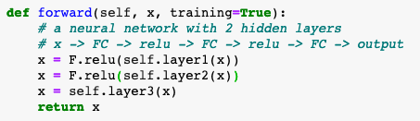

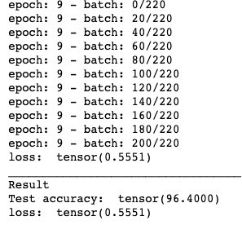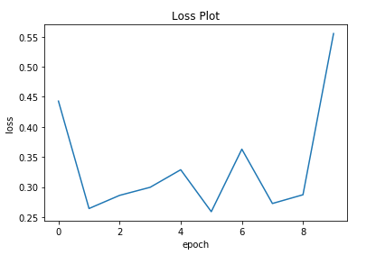

Through my observations when I used dropout layers for MLP it gave slightly better result and less loss spiking between epochs.

Test Accuracy rate: 96.4000

Loss: 0.5551

1. **Learning Rate Comparison MLP**

Next, I have compared different learning rates by keeping the rest the same so we can make better comparison. (Dropout layers used)

lr = 0.001

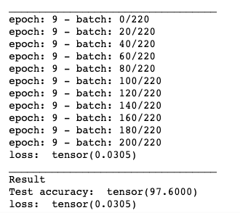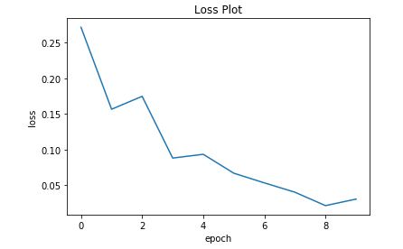

lr = 0.01

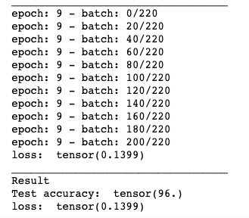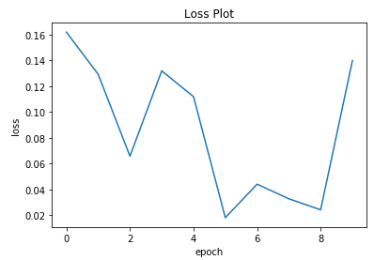

lr = 0.0001

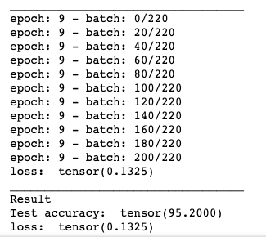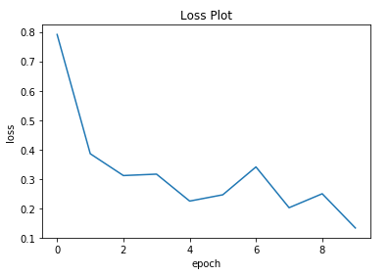

When look at the results we can see that learning rate of 0.001 gave us the most accurate results among these 3.

1. **Epoch size 10 vs 20 MLP**

Since I have done with the results with epoch size 10 I will just show he results with epoch 20. Also, I will be using the same layers I gave which contained the dropout layers so we can compare the two.

**Epoch 10**

Test Accuracy: 97.2000

loss of 0.2002.

**Epoch 20**

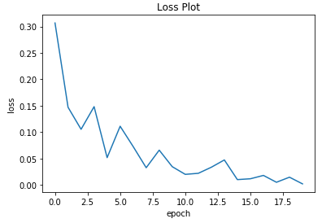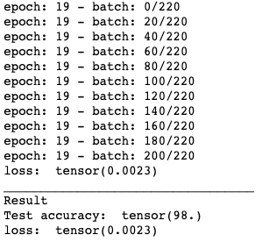

Increasing the epoch has also increased our test accuracy and significantly lowered our loss.

**CNN**

1. **With and without dropout layer CNN**

In my assignment I have modelled my network with and without dropout layer in CNN. The autoencoder has 3 con layers and 3 deconv layers (transposed conv). All layers but the last have ReLu

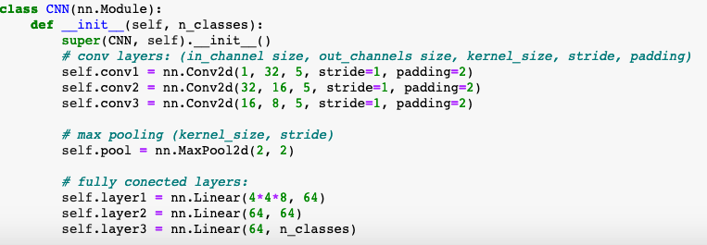

**With Dropout Layer CNN**

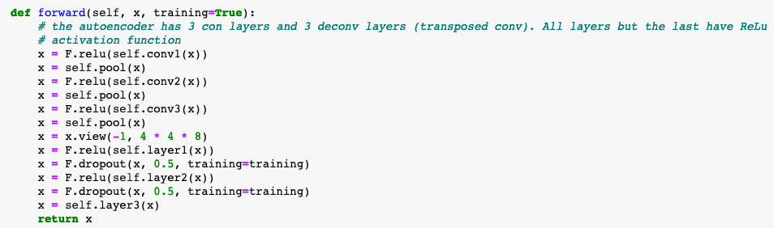

When I ran this code, the results are obtained as shown below:

batch_size = 250

epoch_num = 10

lr = 0.001

disp_freq = 20

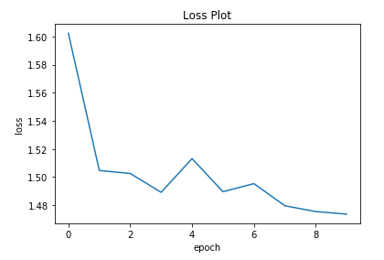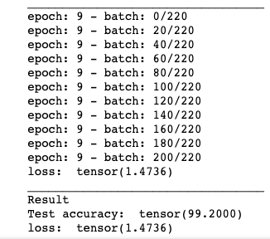

T he test accuracy that I obtained was the best result in my report with an impressive 99.2000 accuracy. The validation loss was also really good.

**Without Dropout Layer CNN**

batch_size = 250

epoch_num = 10

lr = 0.001

disp_freq = 20

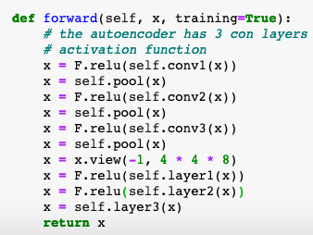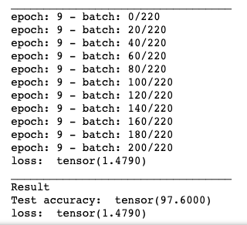

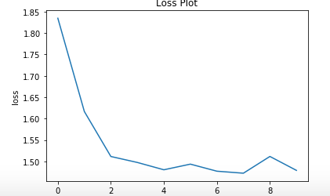

The testing accuracy and validation loss performed really well when the dropout layer was used but not as good as when dropout layer was used.

1. **Learning Rate Comparison CNN**

Next, I have compared different learning rates by keeping the rest the same so we can make better comparison. (Dropout layers used)

lr = 0.001



lr = 0.01

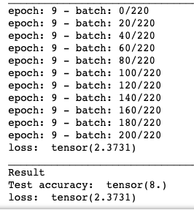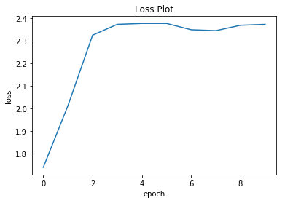

lr = 0.0001

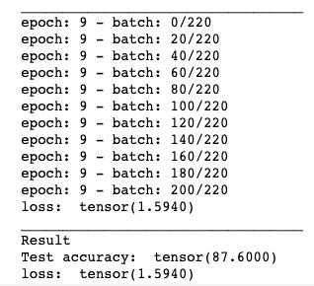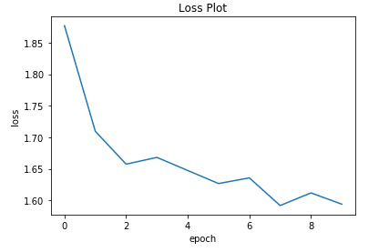

When look at the results we can see that learning rate of 0.001 gave us the most accurate and the best result. However lowering the lr to 0.0001 dropped the testing accuracy rate significantly to 87.6000

1. **Epoch size 10 vs 20 CNN**

Since I have done with the results with epoch size 10 I will just show he results with epoch 20. Also, I will be using the same layers I gave which contained the dropout layers so we can compare the two.

**Epoch 10**

Test Accuracy: 99.2000

loss of 1.4736.

**Epoch 20**

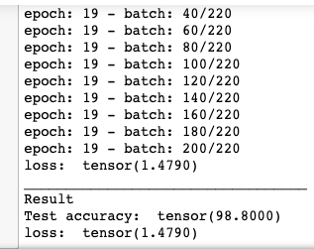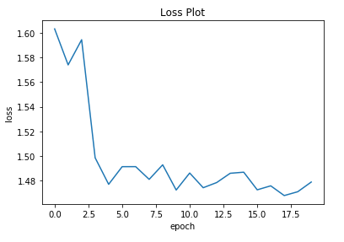

In this case increasing the epoch to 20 hasn’t increased the accuracy rate but decreased it slightly compared to epoch 10.

1. **Final Thoughts of CNN and MLP with TensorFlow Compared to previous Homework**

Firstly when I was training the data I have seen a significant improvement when it came to with pytorch and just numpy implementation from previous homework. This Homework gave me more accurate results while performing much faster.

Secondly, When I compare the MLP and CNN implementation with pytorch. The results obtained was significantly similar but the speed of MLP while doing training was really faster than CNN when it came to training. If you have a poor CPU or GPU I would suggest anyone to use while if you have a powerful CPU or GPU CNN task shouldn’t be a problem because I used my Macbook Air to compute the tasks and I had to wait a long time for CNN.